

Internet Programming

  - Team Members:

  - George Hany Samy 22P0173

  - George Mourad 22P0114

Contents
Introduction 3
Product Backlog 4
User Stories 4
Sprints 5
Sprint 1: 5
Database design 6

Introduction

Social media platforms play an important role in enabling people to communicate, share ideas, and participate in online communities. One of the most popular discussion-based platforms is Reddit, which allows users to create communities, share posts, and interact with others through comments and voting systems.
The objective of this project is to develop a simplified Reddit-like web application that replicates the core features of the platform. The system will allow users to create accounts, join or create communities, publish posts, comment on posts, and interact with content through upvotes and downvotes. In addition, users will be able to search for communities and other users within the platform.
The application will also include an AI-powered feature that allows users to generate summaries of posts, enabling them to quickly understand the main ideas of long content. This feature demonstrates the integration of modern AI tools within web applications.
The project aims to provide hands-on experience in designing and developing a full-stack web application, including database design, API development, frontend user interface, and backend integration. Through this project, we will apply web development concepts to build a functional social media platform that demonstrates both technical and collaborative development skills.

Product Backlog

User Stories
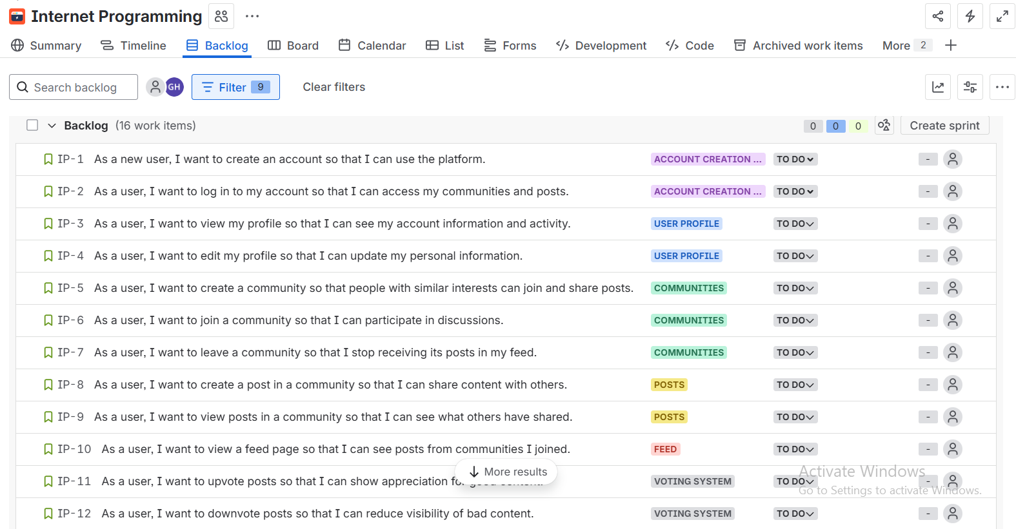

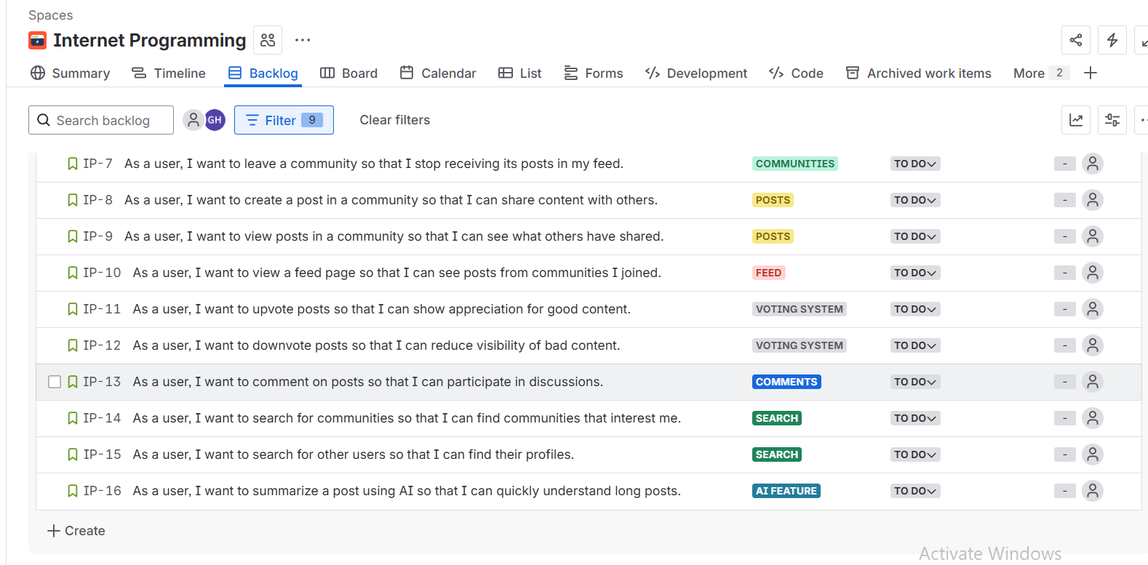

Sprints

Sprint 1:
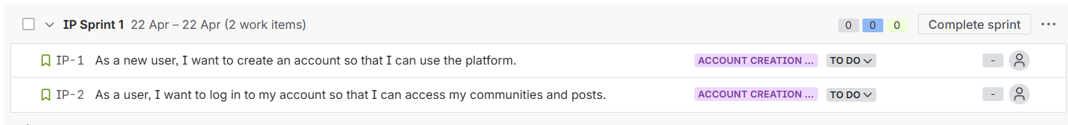

Database design
